**Error003: WebConnectionStrings.config is being ignored by VS**

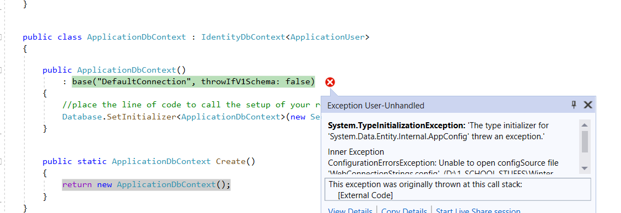

**Description:** WebConnectionString.config is missing because it is being ignored by VS that’s why this error is occurring. It’s also missing from the github masters/origin.

**Solution:** Unresolved. I’m still attempting to fix the issue.